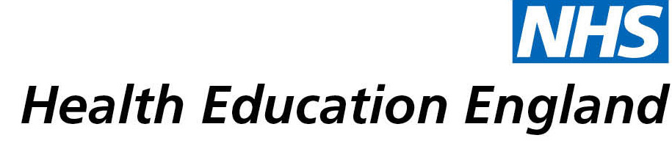

# Library and Knowledge Services case study

# *East London NHS Foundation Trust, Newcomb Library (at Homerton University Hospital): Library contributing to staff wellbeing project*

Date: 2 June 2021

## Reason for enquiry

I am engaged in an initiative to promote staff wellbeing. To this end I am reading widely. I wanted an article and asked the Newcomb Library if they could source it. As they always do, they got back immediately and told me options, minimal sourcing fees (a book needed to be obtained from an external library). I asked if a pdf of a specific chapter were available.

## What the knowledge and library specialist did

A day or two following my request, the chapter appeared in my inbox. They apologised that it was a large attachment. As ever, I was blown over by their utter professionalism and efficiency. This happens every time I use them. It is a joy.

# Impact of input from the library and knowledge service

## Immediate Impact

The short answer is that it saved me spending £31 on a book. However, this is simplistic and the answer is more complicated. It made me happy that the service was so great. It inspired me to be efficient and friendly.

It made me want to tell my colleagues to use the library.

The research I am doing is on staff wellbeing; this experience promoted my wellbeing.

Staff wellbeing in turn is related to efficiency and quality of patient care.

Also, the chapter is a brilliant one which will help me to think about the work I am doing on staff wellbeing. It prompts me to do some teaching for my training doctor colleagues as I recall how every doctor should read this article every couple of years.

It makes me feel grateful to have a workplace with a library.

## Probable future Impact

All of the above. These are things which are not easy to measure. The efficient provision of this service made my work happier and will, I believe, enhance the work I am doing to promote staff wellbeing.

## Submission by:

Elizabeth Venables, Consultant Psychiatrist

East London Foundation Trust

evenables@nhs.net

## For further information on how you can get similar support contact your local NHS library and knowledge service.